Intermediate Algebra Lecture 11.5: Sketching Graphs of Quadratic Functions

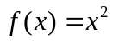

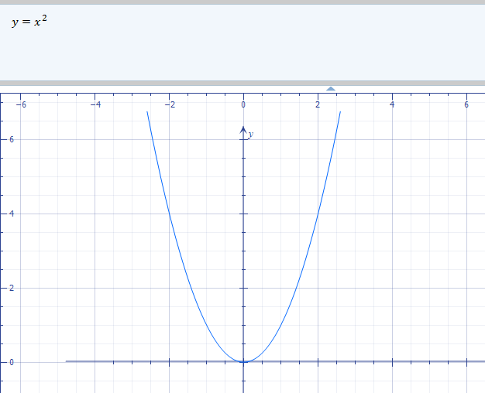

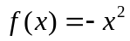

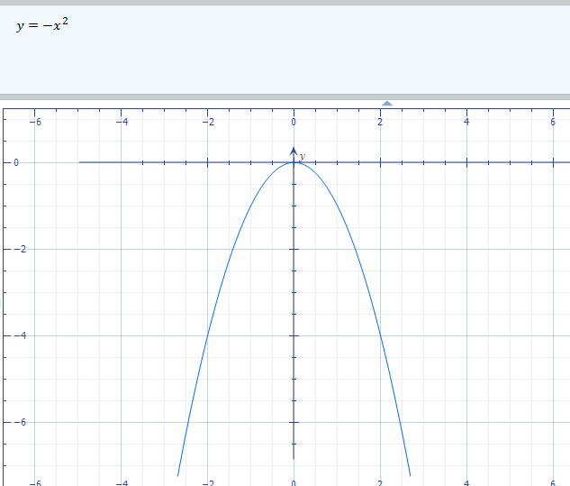

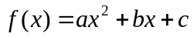 is a quadratic function, graph results in a parabola

Example
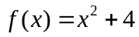

Parabola is shifted up 4

Vertical shifts:
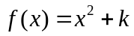 shift up k units
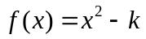 shift down k units

Example

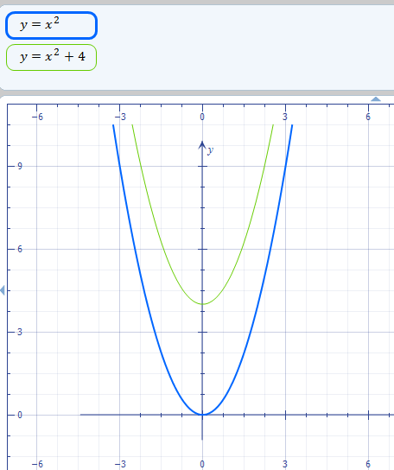

Example
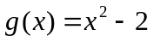

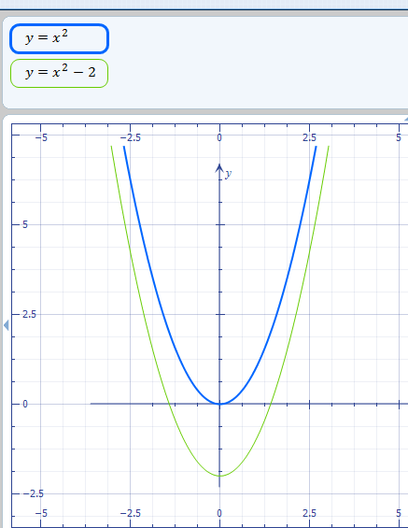

Horizontal shifts:
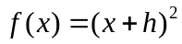 shift left h units
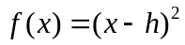 shift right h units

Example
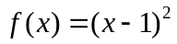
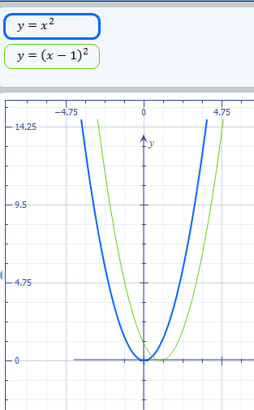

Example
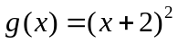
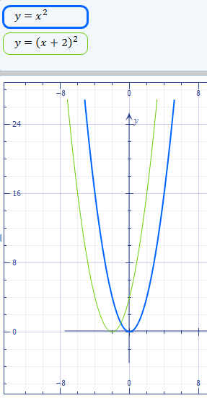

Example
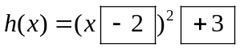
Right Up
2 3

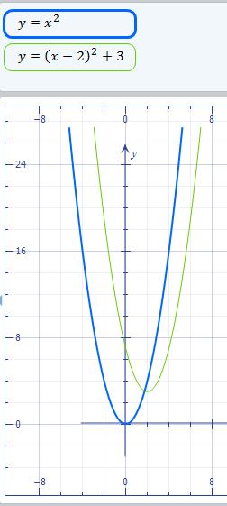

Example
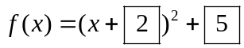
Left up
2 5
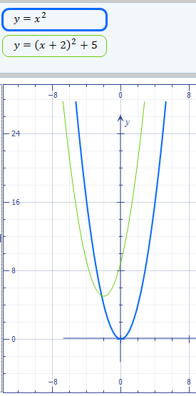

Example
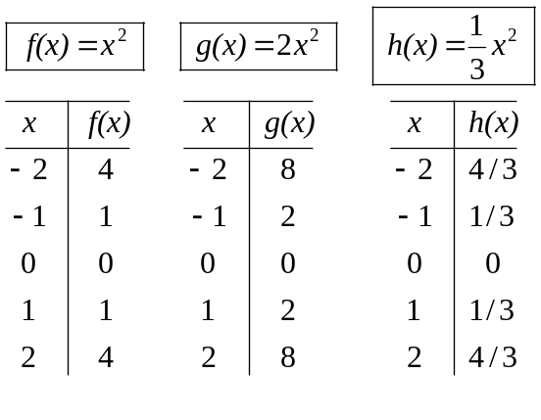

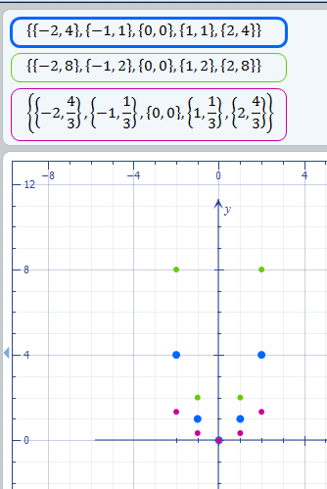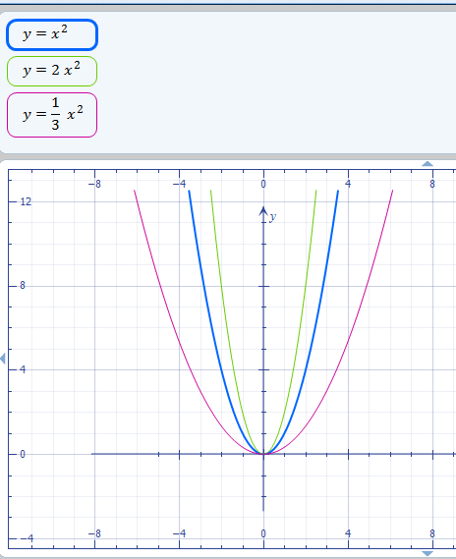

Notes:
is a quadratic function, graph results in a parabola
- If “a” is positive then parabola opens upward a>0 else if “a” is negative then parabola opens downward a<0
- If |a |>1 graph is made narrower (larger the number the graph is decreasing in width)
- If |a |<1 graph is made wider (smaller the number the graph is increasing in width)

Example
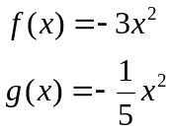
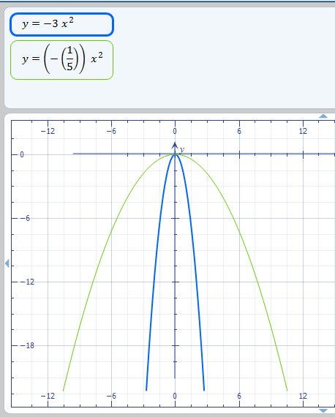

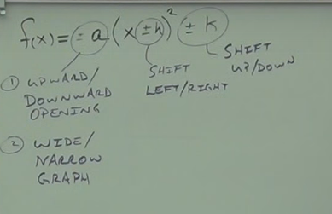

Example
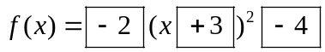
Notes 1 2 3

- Opens downward and narrower than a 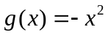 graph
- Left by 3 units
- Down shifted by 4 units

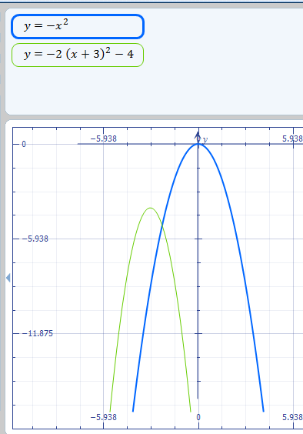

Example
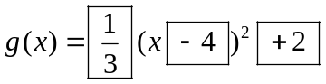
Notes 1 2 3

- opens upward and a wider parabola than a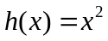
- Right 4 units
- Up by 2 units

